NAME: NAVODITAA A R ROLL NO:241901071
11. EXPLORE TOR NETWORK FOR ANONYMOUS COMMUNICATION
DATE:01/04/2026
Aim:To understand and use the Tor network for secure and anonymous communication.
Procedure:
- Log into TryHackMe and open the Tor room.
- Study the basics of the Tor network and its purpose.
- Understand how traffic is routed through multiple nodes for anonymity.
- Install and launch the Tor Browser.
- Explore secure browsing and verify anonymity using test methods.
- Learn limitations and risks associated with Tor usage.
- Complete the tasks and confirm completion.
Tasks:
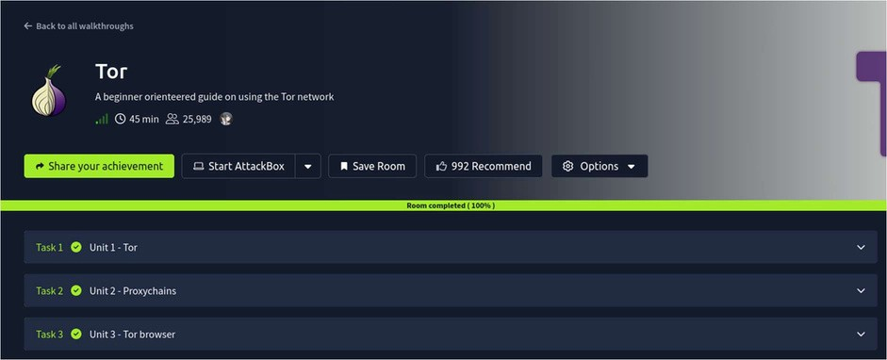
TASK 1 – Unit 1-Tor
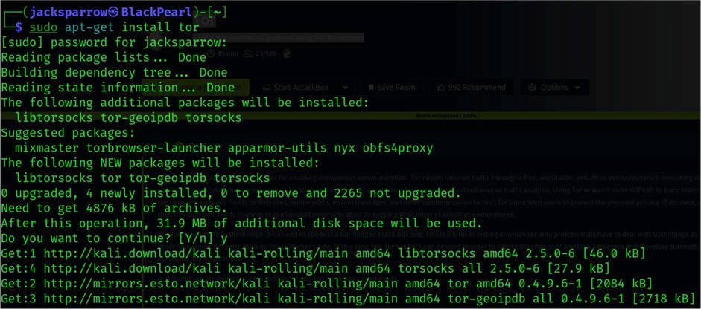
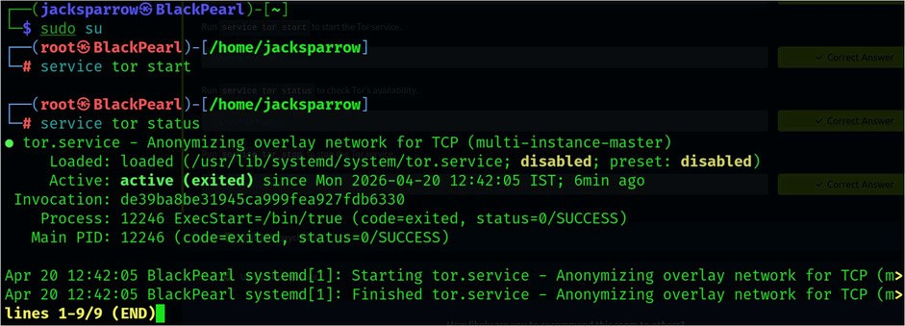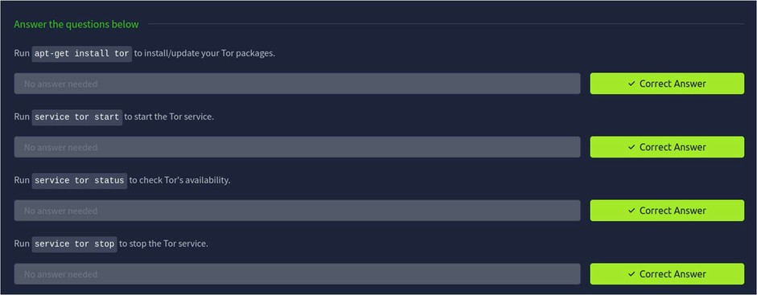
TASK 2 – Unit 2-ProxyChains
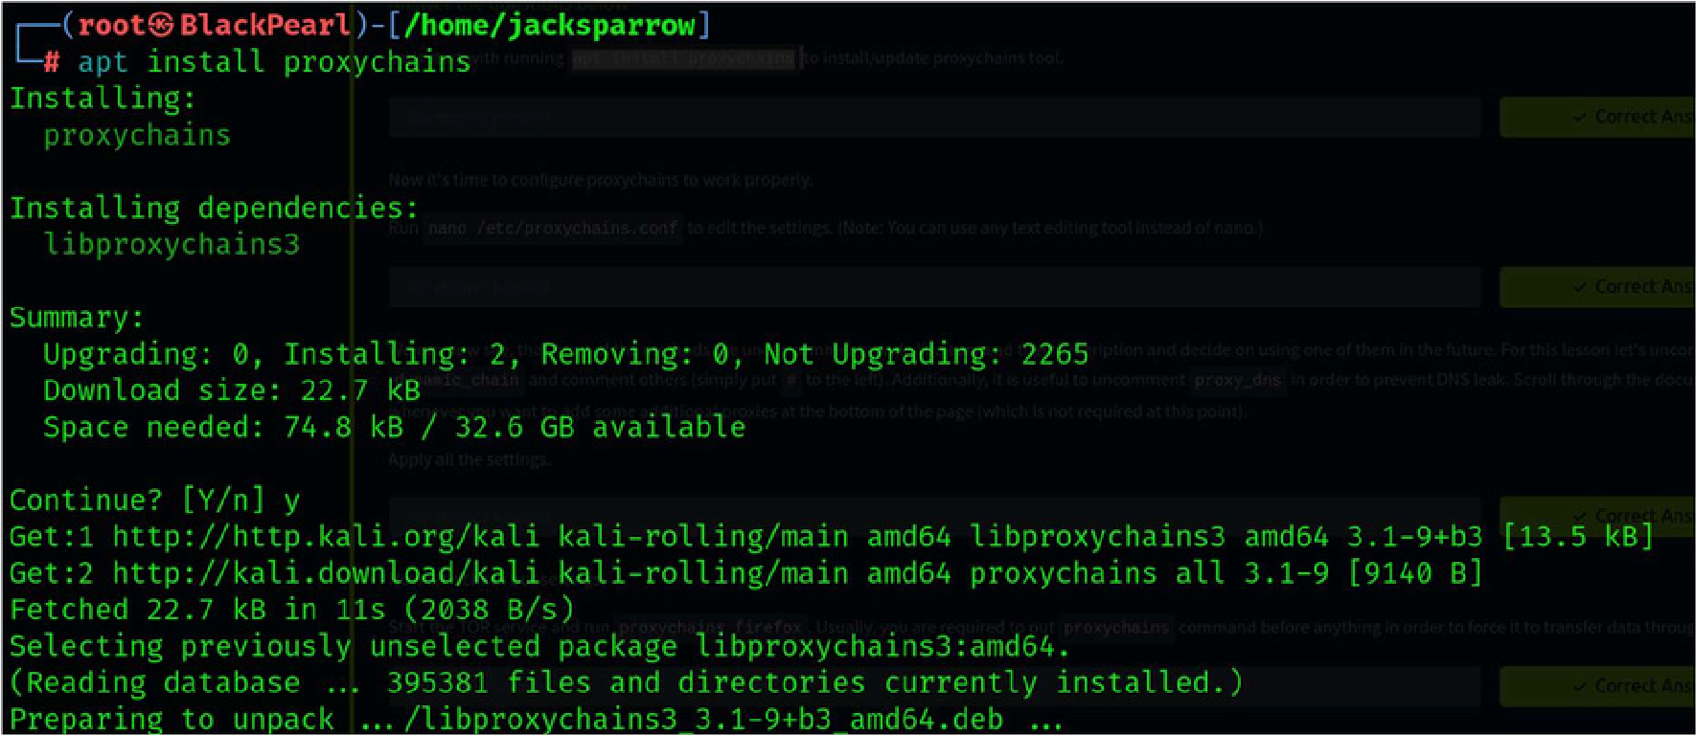
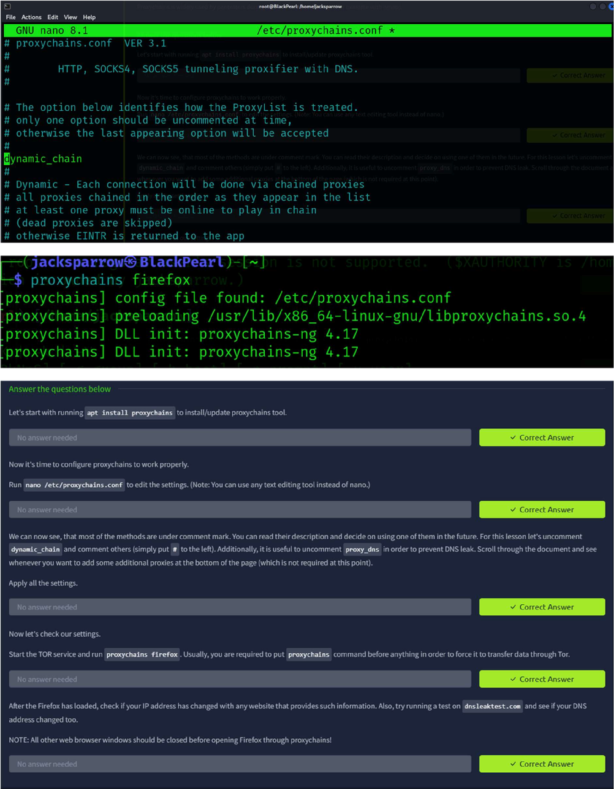
TASK 3 – Unit 3-Tor Browser
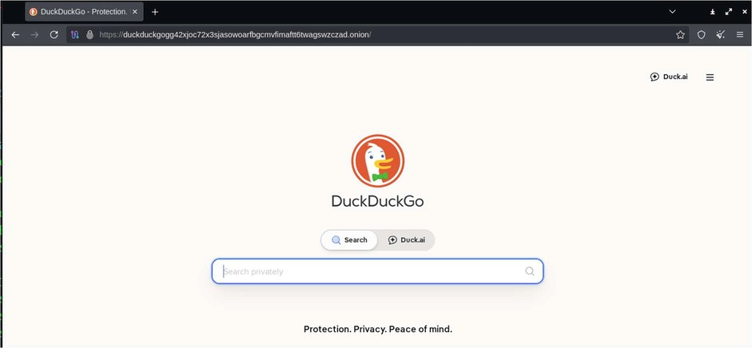
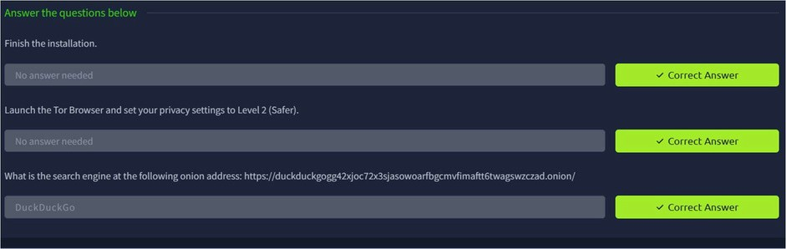
Result:
Thus the TryHackMe room “Tor” was completed successfully.

